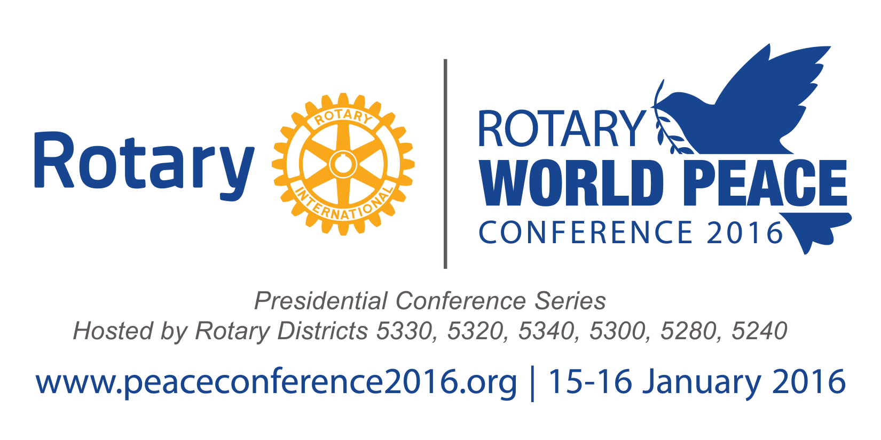
Medical and Liability Release Form

Rotary World Peace Conference –Interact World Peace Conference
Saturday, January 16, 2016

MUST BE COMPLETED FOR ALL STUDENTS
Please Print Clearly and Return with Registration Form

Student’s Name: _____________________________________________________________________________________

Address: _______________________________________________ City: ________________________ Zip: ____________
Parent or Guardian: ____________________________________________Relationship ____________________________

Home Phone: __________________________________ Cell:__________________________________________________
Other Emergency Contact: ___________________________________ Phone: __________________________________

Medical Insurance Provider___________________________ Policy Number ____________________________________

Insured’s Name_________________________________________________________________________

Medical Transportation, Activity and Photo Release

I give permission to Rotary District 5330, 5320, 5340, 5300, 5240 and 5280, Rotary World Peace Conference 2016, Rotary International, Radisson Ontario Airport, Stop Hunger Now, and its agents to select transportation to a medical provider who may provide proper treatment for, hospitalization of, order injections, X-ray examinations, anesthesia or surgery for my child as named above. The above named agent is authorized to make medical decisions concerning the health and welfare of my child.

I voluntarily elect to allow the above named to participate in activities and assume the risk of injury or harm that could result from participation. On my own behalf and that of my personal representatives and heirs, I hereby release Rotary District 5330, 5320, 5340, 5300, 5240 and 5280, Rotary World Peace Conference 2016, Rotary International, Radisson Ontario Airport, Stop Hunger Now, its officers, employees and agents from all liability from any injury or harm to my child (or minor) from participating in any activity at the World INTERACT conference at the Radisson Hotel, whether the injury or harm is caused by accident or by negligence or otherwise.

I hereby agree that Rotary District 5330, 5320, 5340, 5300, 5240 and 5280, Rotary World Peace Conference 2016, and Rotary International may use any type of audio and/or visual records of this program for its promotional and/or commercial purposes without compensation.
I have read, understand, and agree to the above. My child may participate in any activity except as I have noted on the reverse side of this form.
Parent/Guardian Signature:

__________________________________________________________________Date_______________

